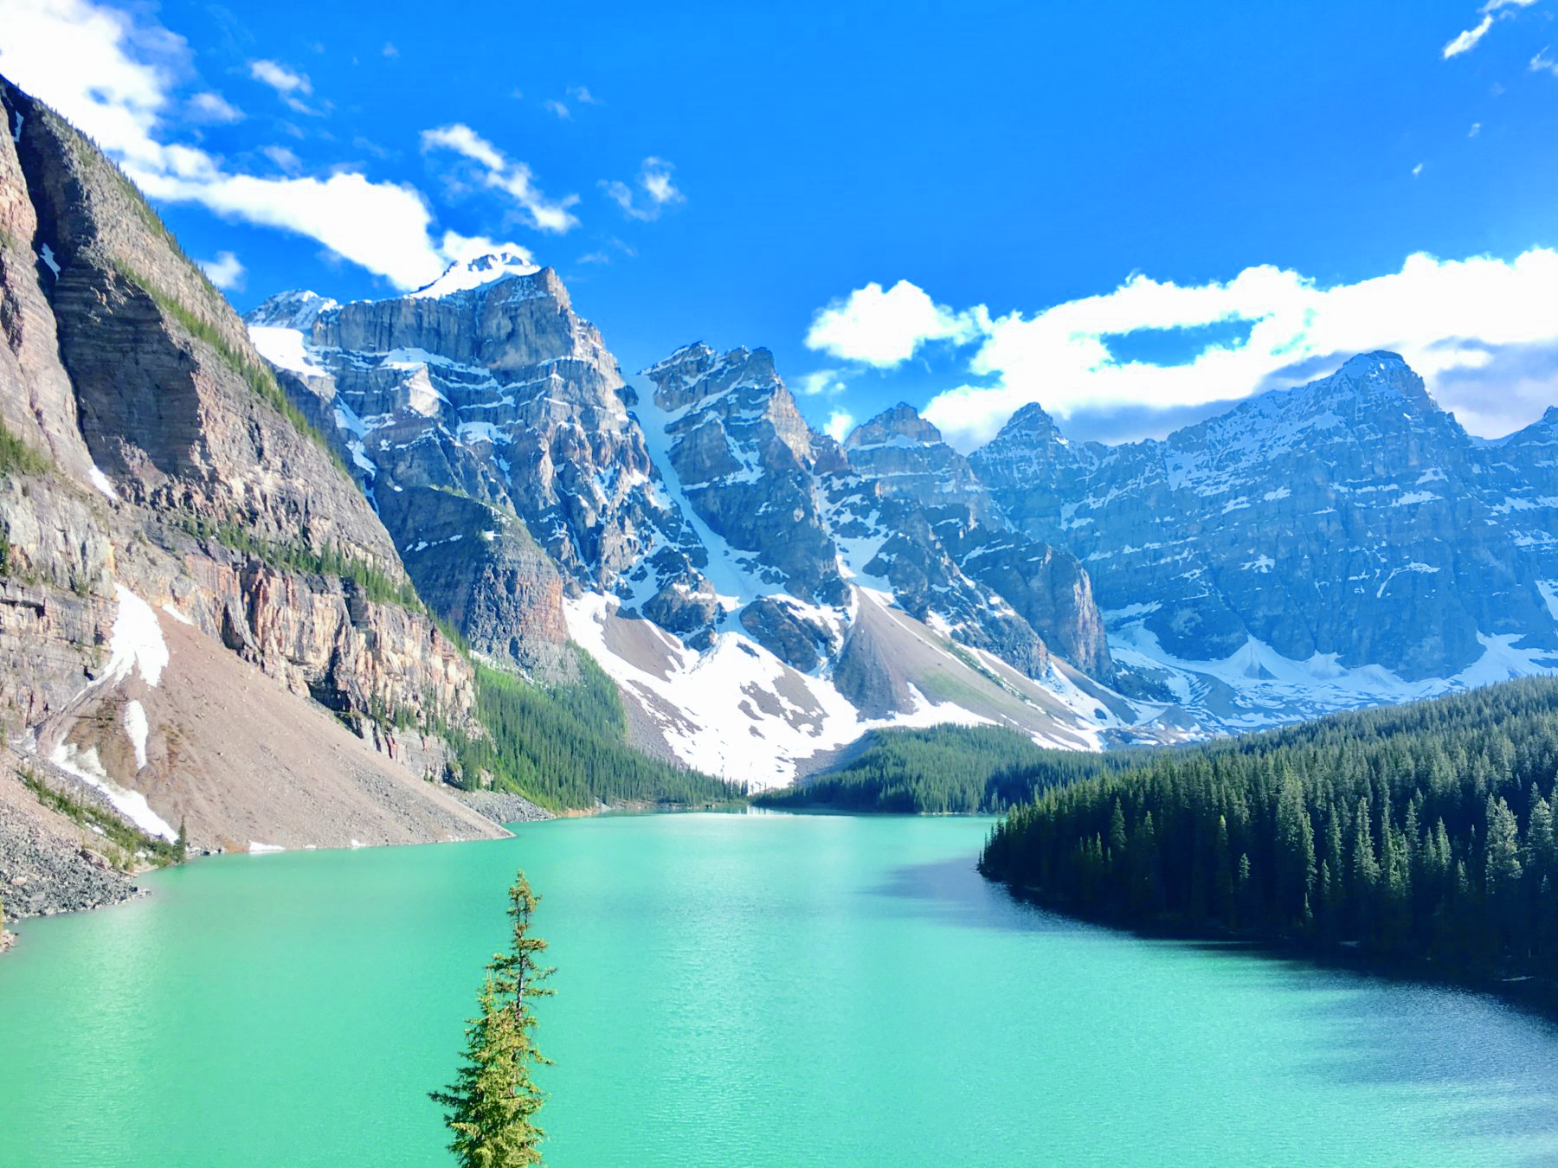  - August 10-17, 2024  Canadian Rockies including Banff, Lake Louise and touring Glacier National Park  Tour with FGCCT  This is the tour you have been waiting for! Next year our annual National Parks tour begins in Calgary and allows us to spend time in spectacular Banff and Lake Louise. Then we move down to Glacier and Waterton Lakes National Parks where together they form one of the most beautiful regions of mountains and alpine lakes on earth. See this awe-inspiring area from both sides of the border on this exciting tour. | Five National Parks in Canada and the Rockies  ____  Calgary Botanical Gardens Cascades of Time Garden  ____  Jammer Tour in Glacier over Going to the Sun Road  ____  Ice Explore Ride on the Athabasca Glacier  ____  Passport Essential!  Pre Night available  Federated Garden Clubs of CT.  Kathy Lindroth  Tour Coordinator  Kathleen.Lindroth@gmail.com
Canadian Rockies & Glacier National Park
August 10-17, 2024
Round Trip Calgary, Canada

Saturday, August 10, Day 1 – Arrive Calgary - Banff

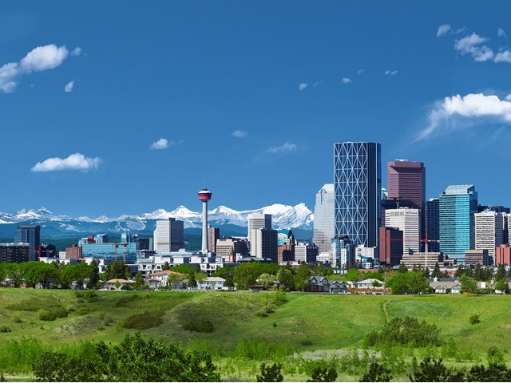
Welcome to Canada and Calgary Alberta! On arrival at Calgary International Airport, pass through Canadian Customs and Immigration and meet our guide. *Please arrive at Calgary Airport no later than 3:00pm* Hotels near the airport with shuttles are available if you wish to arrive a day early. Group rates for a pre-night will be forthcoming.
Then board a deluxe motorcoach for a scenic drive to Banff National Park. With the silhouette of the city of Calgary in the background, we’ll head west along the Trans-Canada Highway. Watch the foothills quickly give way to the rugged peaks of the Rocky Mountains and Banff National Park. Traveling along the banks of the Bow River we’ll start to see the incredible beauty of the area that will surround us for the next week. Arriving in the resort town of Banff, check in to our comfortable hotel and then enjoy a “welcome to the Rockies” dinner. Banff Caribou Lodge, 2 nights. (D)

Sunday, August 11, Day 2 – Banff
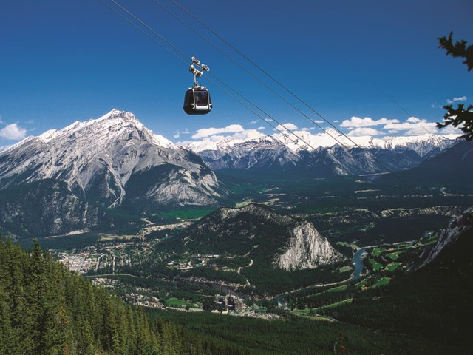
Start the morning with a hearty breakfast then join the rest of our group for an exciting tour of Banff. A gondola ride to the top of 7500 ft Sulphur Mt will give us an amazing panorama view of over 50 miles in every direction. It’s a great opportunity to view the Bow Valley, Lake Minewanka and the town site of Banff from high above. Returning to the valley we’ll travel beside Tunnel Mountain, view the cascading Bow Falls and spend some time touring the beautiful Cascades of Time Gardens of the Park Headquarters. After a viewing of the mysterious “Hoodoos” and the historic Banff Springs Hotel our tour comes to an end leaving us with the full afternoon to explore the shops, museums, cafes, and nearby trails of Banff. (B)

Monday, August 12, Day 3 – Lake Louise - Yoho
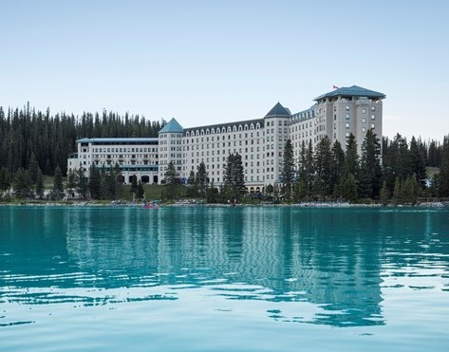
Today’s adventure starts with a journey west along the banks of the Bow River to Lake Louise Village. From there we make a scenic climb from the valley up the mountain road to the stunning landscape of azure blue Moraine Lake and the Valley of the Ten Peaks. Take
your time and enjoy the peaceful beauty of the lake, and the beautiful Moraine Lake Lodge. Later in the morning, our journey continues to the “Jewell of the Rockies”-- Lake Louise. There will be time to enjoy a walk along the lakeshore and explore the shops and galleries of the iconic Chateau Lake Louise. Enjoy some lunch (on your own) before boarding the coach for a short journey along the Trans-Canada Highway to enter the province of British Columbia and Yoho National Park. There will be lots of time to marvel at the beauty of Emerald Lake, the Natural Bridge, and the Famous Spiral Tunnels before we return to the province of Alberta and arrive in Lake Louise Village. We’ll check into our relaxing accommodation for the next two nights. And enjoy the opportunity to explore the area and review the many highlights of the day. (B, D) Lake Louise Inn, 2 nights

Tuesday, August 13, Day 4 – Icefield Parkway
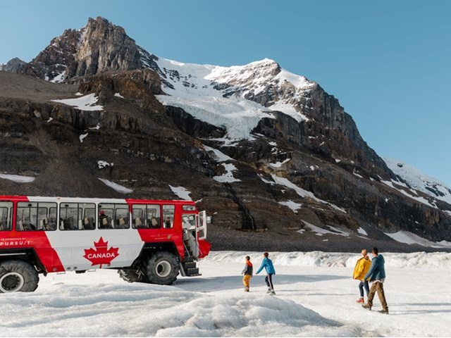
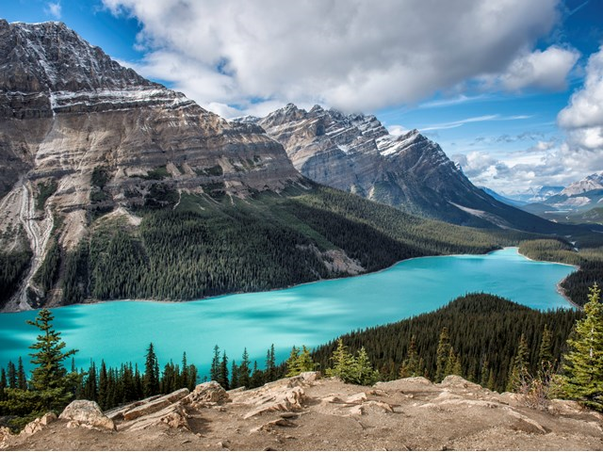
Today travel along one of the world’s most spectacular highways, the Icefields Parkway. We follow the Bow River west before heading north into some of the most spectacular mountain vistas in the world. We’ll climb to the summit of Bow Pass to view the azure blue Peyto Lake before continuing along the Mistaya (Grizzley) Canyon to the crossing of the North Saskatchewan River. A spectacular climb to the summit of the Sunwapta Pass brings us into Jasper National Park and the vast expanse of the Columbia Icefields whose waters feed three Oceans. A special treat awaits as we board the gigantic Ice Explorer vehicle and drive out onto the mile-thick Athabasca Glacier…truly a once in a lifetime experience. Our return journey will include a stop at Bow Lake, the headwaters of the mighty Bow River. Our day comes to an end as we return to our comfortable accommodation in the beautiful Lake Louise Valley. (B)

Wednesday, August 14, Day 5 – Kananaskis – Waterton Lakes
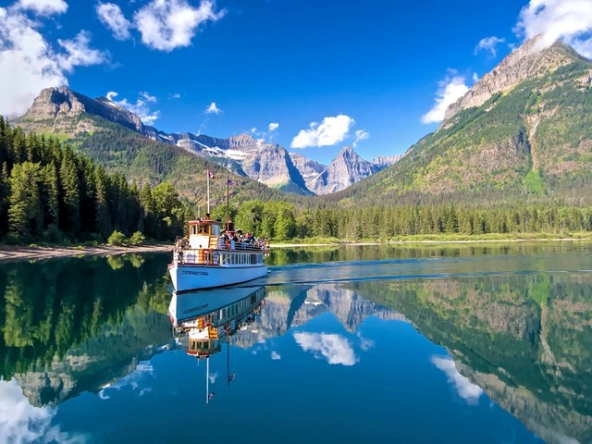
Put on your cowboy boots and get saddled up for the great day ahead! As our coach leaves Banff National Park, we’ll journey through the foothills for a short time before heading south through the wilderness of the Kananaskis Valley. Known for its large population of Grizzly Bears, the Kananaskis Valley is truly “the road less taken”. We will be amongst the very few who get to view this beautiful area. Take a break at the rustic Peter Lougheed Park Lodge before continuing to the Historic Bar U Ranch for a Western Lunch and a walking tour of this beautifully kept historic site. Once the biggest ranch in North America, the Bar Us is home to the largest herd of Percheron Horses in Canada. Our day’s journey comes to an end as you arrive in Waterton National Park and settle in at our lakeside accommodation. Tonight, enjoy a short walk to view nearby Cannon Falls. (B, L) Bayshore Resort, 2 nights

Thursday, August 15, Day 6 – Glacier
An international jaunt lies ahead as we make an early morning departure from our hotel and travel to the nearby U.S. border for a day excursion into Montana and Glacier National Park. After a scenic journey though the tribal lands of several American Indian tribes our coach will enter
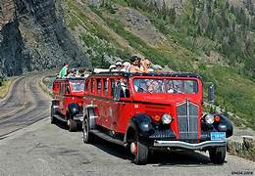
Glacier National Park and drive along placid Lake McDonald to one of America’s oldest and largest Log Hotels, the Lake McDonald Lodge. This will be the starting point of a thrilling ride in the famous 16 passenger open-roofed red buses. Fondly referred to as the “Jammers” the vehicles and their engaging driver/guide will take us on a 3-hour drive along the switchback route of the Going-To-The-Sun Highway. Reaching a summit of almost 6.000 feet this road is one of the most spectacular mountain routes in the world. Arriving safely in the resort community of St. Mary, re-board the comfortable motorcoach and relax as you journey back into Alberta, Canada, and our accommodation on the shores of the shimmering Waterton Lakes. (B)

Day 7 – Cardston - Calgary (8/16 Fri)
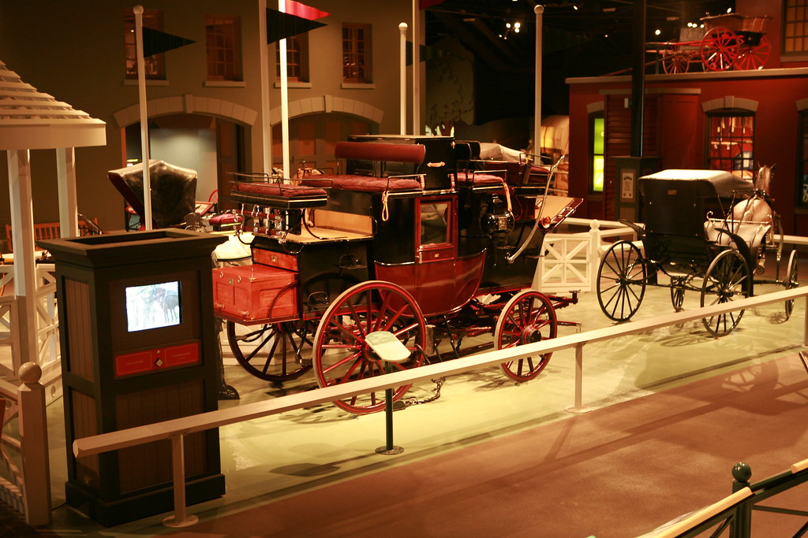
The morning starts with a short ride to the city of Cardston and the Remington Carriage Museum. Here we’ll see one of the finest collections of vintage carriages in North America. This is also one of the only active carriages making facilities that still uses the tools and skills of the 1800’s. Traveling north through the cattle ranches and oilfields of southern Alberta we catch a glimpse of some of the resources which power Alberta’s rapidly growing economy. History unfolds before us as you enter the Head Smashed-In Buffalo Jump, a UNESCO World Heritage Site. Enjoy lunch on your own then a tour that interprets over 6,000 years of Plains Buffalo Culture and the significance of this cliff to the Plains People. Our journey continues north to the vibrant city of Calgary, Oil Capital and famous for the world-famous Calgary Stampede! We’ll do a short tour of the city before stopping to visit the Calgary Tower. This is a great place to view the majestic Rockies to the west and the vast grazing lands and prairies to the east. This evening, enjoy a special farewell dinner with your travel companions and compare notes about your amazing Rockies adventure.
Delta Calgary West , Calgary, (B,D)

Saturday, August 17, Day 8 – Journey Home
Your Canadian Rockies and Glacier National Park adventure comes to and end with a morning transfer to the Calgary International Airport for your flight home. (B)

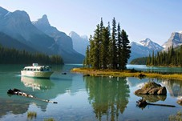

Tour Pricing
Based on 30 Paid Passengers
$4124 Per Person Double Occupancy
$5509 Single Supplement (Single Rooms Limited)
$100 Non-Member Guest Fee, Spouses excluded from surcharge

Tour Includes:
Private Motor Coach Transportation & Services of a Professional Driver
Services of a Professional Tour Manager
Accommodation for 7 nights
7 breakfasts, 1 lunch, 3 dinners
National Park entrance fees
Sulphur Mountain Gondola
Lake Louise and Bow Valley Parkway
Ice Explore Ride on the Athabasca Glacier
Red Bus tour of Glacier National Park over Going to the Sun Road
Remington Carriage Museum
Head Smashed in Buffalo Jump
Calgary Tower
Baggage Handling (1 main piece of luggage per person)
Gratuities for included meals
Applicable Taxes and Fees
GRATUITIES INCLUDED FOR DRIVER AND TOUR DIRECTOR!!
$100 Donation per person to FGCCT (Nonrefundable)
Snacks on the motorcoach

Not Included:
Airfare
Optional Activities
Items of a personal nature (alcohol, room service, etc.)
Meals (other than listed in the itinerary)
Trip Insurance (required)
Note: Please arrive at Calgary Airport no later than 3:00pm on August 10 for start of tour. Hotels near the airport with shuttles are available if you wish to arrive a day early. Group rates for a pre-night will be forthcoming. There are many hotels near the airport with shuttles to rest up for our great trip ahead!

Block of rooms available at Hilton Garden Inn Calgary Airport $145 including taxes/fees, breakfast extra. Please sign up on the registration form. Airport shuttle is available free 24/7.

Terms & Conditions and Important Information

Refund Policy:
Participants who withdraw more than 90 days prior to tour departure will receive a refund less the $100 donation to FGCCT and $200 cancellation penalty.
90-61 days prior to departure-- $1000 per person cancellation penalty
60 days prior—no refund for tour unless covered by your trip insurance
Final payment is due by May 1, 2024

- Space on this journey is limited and registrations are accepted on a first come, first served basis.
- Registration and payment imply acceptance of the terms and conditions described herein.
- Registration and payment waive and release the Federated Garden Clubs of CT, Inc. and Southwest Adventure Tours, their affiliates, directors, officers, employees, including any person or entity employed or utilized by them, from all claims arising from any injury, loss, damage, accident, delay or expense resulting from events beyond their control, including, without limitation: natural disasters, war, strikes, incidents of politically motivated violence, sickness or quarantine, government restrictions or regulations, and in the absence of its own gross negligence, arising from the use of any vehicle or from any act of omission by any bus or car rental agency, airline, taxi or tour service, hotel, restaurant, or other firm , agency, company or individual. Any cancellation due to Acts of God will be refunded with credits to be applied within 24 months.
- Southwest Adventure Tours reserves the right to substitute hotels, activities or excursions in response to changes in availability, local events or weather conditions, provided such substitutions do not adversely affect the overall quality of the tour. Such substitutions do not constitute grounds for withdrawal with full refund.
- Conduct During the Tour: You are responsible for respecting the authority and laws of the countries in your itinerary, including local health and safety regulations, and following the directions of the tour guide. We may exclude you from participating in all or any part of the tour if, in our sole discretion, your health, condition or behavior renders you unfit for the tour or unfit for continuation once the tour has begun. Unfitness may include, without limitation, any behavior that, regardless of its cause, is inappropriate or offensive or interferes with the delivery of tour services or may constitute a hazard or embarrassment. In such case, our liability shall be strictly limited to refund of the recoverable cost of any unused portion of the tour. Should you decide not to participate in certain parts of the tour or use certain goods, included in the tour, no refunds will be made for those unused parts of the tour or goods.

Tour Cost Adjustments
Every effort is made to guarantee that the published cost of your tour will not change. However, we do reserve the right to adjust in the following circumstances: If the number of participants falls under 30 the cost of the tour will be adjusted.

Trip Insurance

Everyone is strongly encouraged to obtain trip insurance within 14 days of making a deposit for maximum coverage. Since this is an international trip, you will need medical coverage on the trip as your USA medical normally will not cover you outside of country. Trip Insurance with COVID coverage is highly recommended. Please visit Squaremouth.com or Insuremytrip.com to get quotes that match your individual needs.

Getting to Calgary

Flights are not part of this tour package. Do not book any flights until you have been notified that we have our minimum number to travel. You must arrive prior to3 pm on August 10, 2024 to begin the tour. Hotels near the airport with shuttles are available if you wish to arrive the day before the start of tour.

Covid Practicalities

It is the responsibility of the travelers to be aware of the current covid 19 situation in the U.S. and Canada. Southwest Adventure Tours, The Federated Garden Clubs of Ct., Inc, and Kathleen Lindroth are not responsible for any costs due to itinerary changes, cancellations, penalties incurred, Covid 19 testing, extended stay in Canada due to positive tests or quarantine requirements by local health officials.

All passengers on this tour must be fully vaccinated (including booster) to participate.

Please bring your refillable water bottle for your personal daily use on or off the coach. No single use plastic bottles will be distributed, although there will be some larger bottles that can be used to refill your bottle if needed. Refill stations are common; we can save the use of hundreds of plastic bottles during this trip alone just by refilling our own bottles.

